**Milestone 1**

**Group D**

***Keya Shah***

***Rohit Pahuja***

***Pradnya Ambre***

***Hema Kotte***

***Karthik Reddy***

**Introduction**

**Transit system is** a type of high-capacity [public transport](https://en.wikipedia.org/wiki/Public_transport) generally found in [urban areas](https://en.wikipedia.org/wiki/Urban_area).Unlike [buses](https://en.wikipedia.org/wiki/Bus) or [trams](https://en.wikipedia.org/wiki/Tram), transit systems are [electric railways](https://en.wikipedia.org/wiki/Electric_railway) that operate on an exclusive [right-of-way](https://en.wikipedia.org/wiki/Right-of-way_(transportation)), which cannot be accessed by pedestrians or other vehicles of any sort, and which is often [separated](https://en.wikipedia.org/wiki/Grade_separation) in [tunnels](https://en.wikipedia.org/wiki/Tunnel) or on [elevated railways](https://en.wikipedia.org/wiki/Elevated_railway). The transit system allows higher capacity with less land use, less environmental impact, and a lower cost. However, there are some drawbacks in the payment method of the NY-NJ Transit system which is addressed in this project and suggestions regarding the improvement of the system is discussed thoroughly.

Transit companies around the world are looking to modernize and expand their fare collection systems to include alternative payment methods. The new payment solution being used in Laval buses is the first of its kind in North America, using EMV contactless technology. Currently, the transit structure of New York and New Jersey area is as follows:

1. New York – MTA(Subway)

2. New Jersey – NJ Transit (Light Rail, Bus, Train)

3. Path (NY-NJ connection)

In the case of NJ Transit, users have to buy separate tickets for bus, train, and light rail each time via online or station machines. Most of the time, consumers find it frustrating to purchase the ticket through separate platforms. There should be a common payment method to overcome this problem so that riders won't have to pay again separately and can use the common debit-like card or prepaid card for the payment in the public transit system.

The shift away from cash has become even more pronounced in recent years, with a growing number of retailers offering contactless payment options, making it easier to pay by card, even for small amounts. Mobile wallets and apps have also contributed to fewer cash payments. How are all these affecting transit companies? Today’s commuters want more flexible fare payment options. Commuters don’t always have exact change or the time to purchase their fares in advance, so it’s harder for them to take public transit. The gap between traditional payment methods and consumer habits is getting wider every year. Commuters, who often use more than one [transit system](https://www.openaccessgovernment.org/more-people-choosing-green-transport-methods/2205/) to get to their destination, are frustrated with having to pay separate fares for each system. The payment solution provided in this project, **One Card Transit,** makes it easier to pay fares – commuters will be much happier and public transit more accessible. They can recharge this prepaid card up to $500. Users can swipe this card in all the premises of MTA, NJ Transit, and Path. The amount will be transferred in the respective accounts of the organization on which premise it was used. Here, we need to assume that all the 3 organizations i.e. MTA, NJ Transit, and Path will coordinate among themselves where they will agree to introduce this prepaid card service for the betterment of riders.

**AS- IS**

1. The user purchases a ticket at one of the transit stations. They agree to pay the amount listed on the screen depending on what ticket they have purchased.
2. The user can pay with cash, credit card or debit card.
3. If the amount paid is correct, the machine will print the ticket and a receipt.
4. If the user needs to switch and get on a different transit side, they must purchase another ticket following the same process.

**Organizational Context**

In this scenario, the three organizations involved are MTA (Subway), Path (NY-NJ connection), NJ Transit (Rail, Bus, Light rail). We assumed that all the organizations i.e. MTA, NJ Transit, and Path have agreed to introduce this prepaid card service for the ease of riders. Users can recharge this prepaid card up to $500. They can swipe this card in all the premises of MTA, NJ Transit, and Path. The amount will be transferred in the respective account of that organization of which premises was used.

**Steeple Factors**

1. Technological- Advanced scanners will be set up on different premises so riders can tap/swipe their card to pay.
2. Environmental- Users won’t need to print multiple tickets anymore which will save paper over the years. Once the card is swiped/tapped, only a receipt will be printed.
3. Legal- The three companies will have legal paperwork done to make sure everyone is following their contracts.
4. Ethical- Each company will receive the money from the users who utilize their transit system.

**Major Stakeholders**

1. NJ Transit
2. Path
3. MTA
4. Riders/Customers
5. External Vendors

**High-Level Diagram**

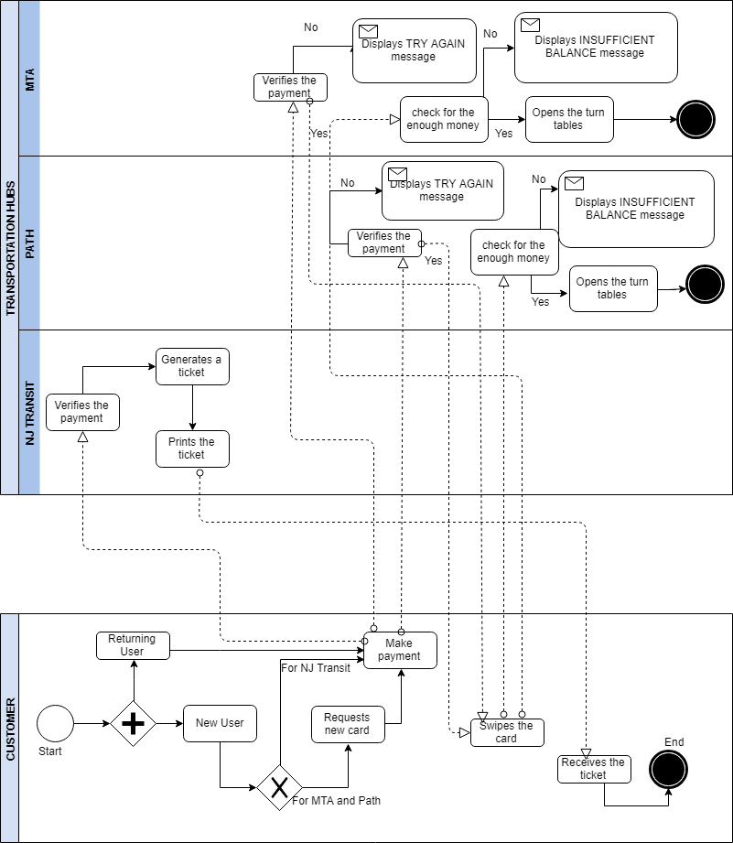

**Further Refinement of the Process Under Discussion**

**Scope Diagram**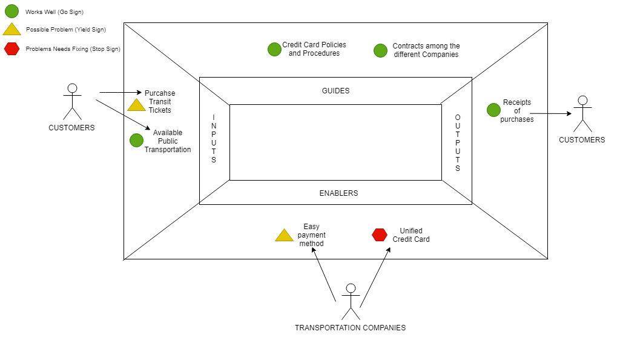

The customer has many available public transportation options to choose from. Once the customer chooses the platform, they need to purchase the ticket to ride the light rail, train or path. The three transportation companies will be in charge of creating a unified credit card which can be used at all stations. There will be contracts in place to protect the three companies so they receive the money fairly when a customer uses the card at their respective station. The customer will get a receipt of their payment made so that their card can be recharged and they are able to ride the different transits.

**Work System Snapshot**

The work system snapshot elaborates components which are participants of the System. The customers are passengers who buy tickets for bus, train, subway and light rail. Most of the time it is difficult for the customers to purchase tickets for different platforms, so a unified debt card is a proposed solution. It’s a prepaid card which can be used by customers for all the platforms. The debit card can be used in all the premises of MTA, NJ Transit and Path. The major stakeholders are NJ Transit, Path, MTA, Developers, Testers, Passengers. Initially, the passenger can recharge his transit prepaid card up to $500.

1) Customer

1. Customers are passengers who use the NJ Transit, Path, MTA services.

2) Product/Service

1. The product is a transit debit card which would serve as a common ticket for NJ Transit, Path, MTA. The customer would have to load their card with the required amount, and they used the same debit card for all the three services (NJ Transit, Path, MTA).

3) Business Process

1. NJ Transit, Path, MTA would be creating a unified debit card which can be used at all stations.
2. Users would load the debit card with the required amount.
3. The three transportation companies would receive money whenever the customers would use their service.
4. The customers would get a receipt of their payments so that they can reload their debit card with the required amount for their next ride.

4) Participants

1. Passengers
2. NJ Transit
3. MTA
4. Path

5) Information

1. The transit debit card serves as a unified payment card for customers who travel in these transportation services.

6) Technology

1. A web-based data distribution system
2. Transaction retrieval system.

**“Problems” or “Opportunities” with the Current Process**

The gaps in the current system in terms of capability and performance are as follows-

1) The current MTA, NJIT Transit and PATH services work independently and offer different services managed by different authorities.

2) They do not have a common payment system or a universal card that works for all modes of transport and thus make commute easy for travelers.

3) On the user side, this leads to managing and refilling different cards and thus affecting the user-friendliness of the system.

4) The current system is time-consuming in terms of adding a certain amount of money to the card.

Conclusively, it is important to improve this business process for the convenience of the commuters. This will save them time by adding money electronically to their transit debit cards. It will also reduce the overhead of managing different cards and thus make the entire process more efficient for the users. Suggested improvements to the business model will be detailed in our TO BE report.